

DEPARTMENT OF COMPUTER SCIENCE AND ENGINEERING

**Laboratory Manual**

**REGULATION 2023**

CS23231 – DATA STRUCTURES

**Dept of Artificial Intelligence and Machine Learning** | **Rajalakshmi Engineering College**

1.

**RAJALAKSHMI ENGINEERING COLLEGE**

**An Autonomous Institution, Affiliated to Anna University**

**Rajalakshmi Nagar, Thandalam – 602 105**



**DEPARTMENT OF COMPUTER SCIENCE AND ENGINEERING**

**CS23231 – DATA STRUCTURES**

**(*Regulation 2023*)**

**LAB MANUAL**

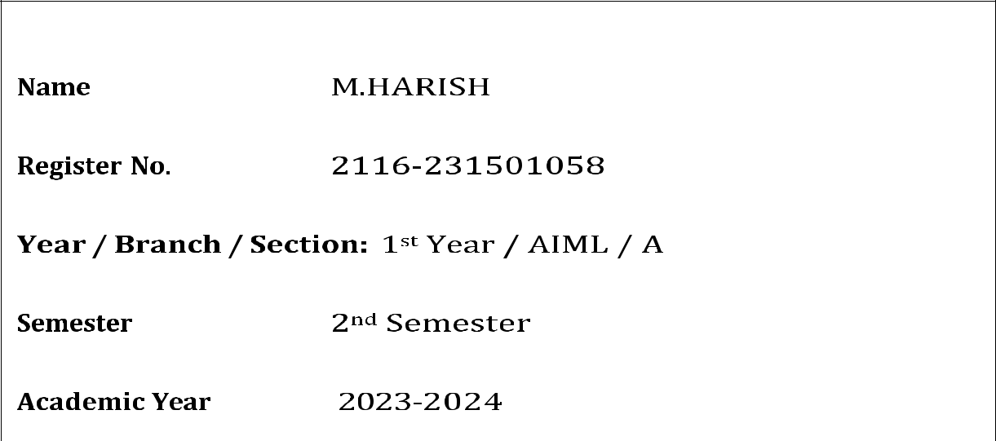

**Dept of Artificial Intelligence and Machine Learning** | **Rajalakshmi Engineering College**

. 2

**LESSON PLAN**

|  |  |  |  |  |  |  |  |  |  |  |  |  |
| --- | --- | --- | --- | --- | --- | --- | --- | --- | --- | --- | --- | --- |
| **Course Code** | | |  | **Course Title** |  | **L** | **T** |  | **P** |  | **C** |  |
|  |  |  |  | **(Laboratory Integrated Theory Course)** |  |  |  |  |  |  |  |  |
|  |  |  |  |  |  |  |  |  |  |  |  |  |
| **CS23231** | |  |  | **Data Structures** |  | **1** | **0** |  | **6** |  | **4** |  |
|  |  |  |  |  |  |  |  |  |  |  |  |  |
|  |  |  |  |  | |  |  |  |  |  |  |  |
|  |  |  |  | **LIST OF EXPERIMENTS** | |  |  |  |  |  |  |  |
|  |  |  |  |  | |  |  |  |  |  |  |  |
| **Sl. No** |  |  |  | **Name of the experiment** | |  |  |  |  |  |  |  |
|  |  |  | | | | | | | | |  |  |
| Week 1 |  | Implementation of Single Linked List (Insertion, Deletion and Display) | | | | | | | | |  |  |
|  |  |  | | | | | | | | | |  |
| Week 2 |  | Implementation of Doubly Linked List (Insertion, Deletion and Display) | | | | | | | | | |  |
|  |  |  |  | | | | | | | |  |  |
| Week 3 |  |  | Applications of Singly Linked List (Polynomial Manipulation) | | | | | | | |  |  |
|  |  |  |  | | | | | | | |  |  |
| Week 4 |  |  | Implementation of Stack using Array and Linked List implementation | | | | | | | |  |  |
|  |  |  |  |  | |  |  |  |  |  |  |  |
| Week 5 |  |  |  | Applications of Stack (Infix to Postfix) | |  |  |  |  |  |  |  |
|  |  |  |  |  | | | | |  |  |  |  |
| Week 6 |  |  |  | Applications of Stack (Evaluating Arithmetic Expression) | | | | |  |  |  |  |
|  |  |  | | | | | | | | |  |  |
| Week 7 |  | Implementation of Queue using Array and Linked List implementation | | | | | | | | |  |  |
|  |  |  |  |  | |  |  |  |  |  |  |  |
| Week 8 |  |  |  | Implementation of Binary Search Tree | |  |  |  |  |  |  |  |
|  |  |  |  |  | |  |  |  |  |  |  |  |
| Week 9 |  |  |  | Performing Tree Traversal Techniques | |  |  |  |  |  |  |  |
|  |  |  |  |  | |  |  |  |  |  |  |  |
| Week 10 |  |  |  | Implementation of AVL Tree | |  |  |  |  |  |  |  |
|  |  |  |  |  | |  |  |  |  |  |  |  |
| Week 11 |  |  |  | Performing Topological Sorting | |  |  |  |  |  |  |  |
|  |  |  |  |  | |  |  |  |  |  |  |  |
| Week 12 |  |  |  | Implementation of BFS, DFS | |  |  |  |  |  |  |  |
|  |  |  |  |  | |  |  |  |  |  |  |  |
| Week 13 |  |  |  | Implementation of Prim’s Algorithm | |  |  |  |  |  |  |  |
|  |  |  |  |  | |  |  |  |  |  |  |  |
| Week 14 |  |  |  | Implementation of Dijkstra’s Algorithm | |  |  |  |  |  |  |  |
|  |  |  |  |  | |  |  |  |  |  |  |  |
| Week 15 |  |  |  | Program to perform Sorting | |  |  |  |  |  |  |  |
|  |  | | | | | | | | | | |  |
| Week 16 | Implementation of Open Addressing (Linear Probing and Quadratic Probing) | | | | | | | | | | |  |
|  |  |  |  |  | |  |  |  |  |  |  |  |
| Week 17 |  |  |  | Implementation of Rehashing | |  |  |  |  |  |  |  |
|  |  |  |  |  |  |  |  |  |  |  |  |  |



**Dept of Artificial Intelligence and Machine Learning** | **Rajalakshmi Engineering College**

. 3

231501058 CS23231 – D a t a S t r u c t u r e s

**INDEX**

|  |  |  |  |  |  |  |  |  |  |  |
| --- | --- | --- | --- | --- | --- | --- | --- | --- | --- | --- |
| **S. No.** | **Name of the Experiment** | | | |  |  | **Expt.** | **Page** | **Faculty** |  |
|  |  |  |  |  |  | **Date** | **No** | **Sign** |  |
|  |  |  |  |  |  |  |  |
| 1 | Implementation of Single Linked List | | | | | | 23/2/24 | 5 |  |  |
|  | (Insertion, Deletion and Display) | | |  |  |  |  |  |  |  |
|  |  | | | | | |  |  |  |  |
| 2 | Implementation of Doubly Linked List | | | | | | 1/3/24 | 11 |  |  |
|  | (Insertion, Deletion and Display) | | | |  |  |  |  |  |  |
|  |  |  |  |  | |  |  |  |  |  |
| 3 | Applications | of | Singly | Linked | | List | 8/3/24 | 17 |  |  |
|  | (Polynomial Manipulation) | | |  |  |  |  |  |  |  |
|  |  | | | | | |  |  |  |  |
| 4 | Implementation of Stack using Array and | | | | | | 15/3/24 | 21 |  |  |
|  | Linked List implementation | | |  |  |  |  |  |  |  |
|  |  | | | | |  |  |  |  |  |
| 5 | Applications of Stack (Infix to Postfix) | | | | |  | 5/4/24 | 24 |  |  |
|  |  | | | | | |  |  |  |  |
| 6 | Applications of Stack (Evaluating Arithmetic | | | | | | 12/4/24 | 27 |  |  |
|  | Expression) |  |  |  |  |  |  |  |  |  |
|  |  | | | | | |  |  |  |  |
| 7 | Implementation of Queue using Array and | | | | | | 19/4/24 | 29 |  |  |
|  | Linked List implementation | | |  |  |  |  |  |  |  |
|  |  | | | | |  |  |  |  |  |
| 8 | Performing Tree Traversal Techniques | | | | |  | 17/5/24 | 31 |  |  |
|  |  | | | | |  |  |  |  |  |
| 9 | Implementation of Binary Search Tree | | | | |  | 17/5/24 | 34 |  |  |
|  |  | | |  |  |  |  |  |  |  |
| 10 | Implementation of AVL Tree | | |  |  |  | 24/5/24 | 38 |  |  |
|  |  | | |  |  |  |  |  |  |  |
| 11 | Implementation of BFS, DFS | | |  |  |  | 24/5/24 | 41 |  |  |
|  |  | | | |  |  |  |  |  |  |
| 12 | Performing Topological Sorting | | | |  |  | 24/5/24 | 45 |  |  |
|  |  | | | |  |  |  |  |  |  |
| 13 | Implementation of Prim’s Algorithm | | | |  |  | 31/5/24 | 47 |  |  |
|  |  | | | | |  |  |  |  |  |
| 14 | Implementation of Dijkstra’s Algorithm | | | | |  | 31/5/24 | 49 |  |  |
|  |  | | |  |  |  |  |  |  |  |
| 15 | Program to perform Sorting | | |  |  |  | 31/5/24 | 51 |  |  |
|  |  |  |  | |  | |  |  |  |  |
| 16 | Implementation | of | Collision | | Resolution | | 31/5/24 | 54 |  |  |
|  | Techniques |  |  |  |  |  |  |  |  |  |
|  |  |  |  |  |  |  |  |  |  |  |



**Dept of Artificial Intelligence and Machine Learning** | **Rajalakshmi Engineering College**

. 4